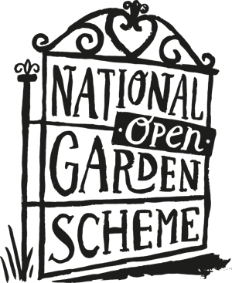

**NEWS RELEASE**

**FOR IMMEDIATE RELEASE 9 June 2020**

**BEECH’S MARK CENTENARY WITH A**

**CAMPAIGN IN SUPPORT OF NGS CHARITIES**

**Beech’s *Fine* Chocolates and The National Garden Scheme, today announce a 6 month campaign, starting on 1 June 2020, the aim of which will be to raise significant funds for National Garden Scheme Charities. Between 1 June and 31 December this year Beech’s will be donating 15% of all sales originating from the campaign promotions undertaken by both organisations. Beech’s fruity flavoured fondant range is bound to be a pertinent choice this summer, with truffles and other festive specialities likely purchases as winter beckons.**

Since 1920 Beech’s Fine Chocolates have been successfully producing luxury,

hand finished products at its Preston factory. Still family owned, the

Beech’s *Fine* Chocolate heritage brand now comprises a 126 strong product range, and the

Group also own the vibrant Jenny Wren brand, which adds a further 20 products

to the overall portfolio available to customers who specifically support this campaign.

Speaking today, Peter Whiting, MD of Beech’s Confectionery Group comments ‘*linking with*

*another quintessentially British brand like the National Garden Scheme with an offer that*

*not only supports vital nursing charities but also provides a much needed treat for less,*

*seems like a mix of perfect ingredients with which to mark our centenary year.’*

/over

***……continued – Beech’s mark centenary with a campaign in support of NGS charities***

The National Garden scheme also has a rich and interesting history in terms of National

heritage – with humble beginnings in the early 1900s, when it first started supporting

district nurses, to donating millions of pounds to nursing and health charities over 90

years later. Over 3,700 exceptional private gardens in England and Wales participate

in the NGS scheme and thanks to the generosity of garden owners, volunteers and

visitors a total of £58 million has been donated to nursing and health charities to date.

In 2019 the annual donation was £3 million, with core beneficiaries including Macmillan

Cancer Support, Marie Curie, Hospice UK and The Queen’s Nursing Institute.

Commenting on the partnership National Garden Scheme CEO, George Plumptre*, says ‘at a*

*time when our gardens have been closed and are only just re-opening, and charities are*

*finding it difficult to raise funds, this partnership with Beech’s is a lovely way to support our*

*work*.’

**IMAGE FILE:**

**http://www.brandemarketing.com/beechs-media/**

**CONTACTS:**

***Beech's Confectionery Group (www.beechsfinechocolates.com)***

Mr Peter Whiting, Managing Director

Landline: 01772 792808

Mobiles: Peter Whiting: 07525 863929

pwhiting@beechsgroup.com

***Brand e Marketing (Press & PR)***

Julia Brand, Principal

Mobile: 07530 345302, e.mail: [info@brandemarketing.com](mailto:info@brandemarketing.com)

**National Garden Scheme (www.ngs.org.uk)**

Ms Vicky Flynn, Communications Manager

Landline: 01483 213908, mobile: 07980 135909

e.mail: vicky@ngs.org.uk